**Assignment 18**

**1. What are comments and what is the importance if commenting in any**

**code?**

* Comments provide context, explanations, and documentation about the code's purpose, functionality, and logic. They are meant to make the code more understandable and maintainable, both for the original author and for other developers who might work on the code in the future. comments can be added to cells to provide additional information about the data or formulas used in those cells. Comments can include explanations, reminders, warnings, or any other text that helps the user understand the purpose of the data or formula.

1. **What is Call Statement and when do you use this statement?**

* It is refer to invoking a subroutine or function from within VBA code. In VBA, you can use the Call keyword to execute a subroutine or function. Call statement is used to execute a subroutine or function. It's a way to explicitly indicate that you are invoking a subroutine or function, and it's typically followed by the name of the subroutine or function you want to call.

**3. How do you compile a code in VBA? What are some of the problem that**

**you might face when you don’t compile a code?**

1. [Download the VbaCompiler for Excel](https://vbacompiler.com/download/) on your computer.
2. Install the VbaCompiler for Excel.
3. Enable “Trust access to the VBA project object model” MS Excel option by

following the path:

Excel Options >> Trust Center >> click button “Trust Center Settings…” >> Macro

Settings >> enable check box “Trust access to the VBA project object model”

1. Examine your VBA code for syntax errors.
2. Make backup copy of the file you are going to compile.
3. Remove the VBA Project password in the file you are going to compile.
4. Run VbaCompiler for Excel by clicking the shortcut on the Windows desktop.
5. Enter the name of file you want to compile.
6. Enter the output folder where resulting files/modified excel file and Windows DLL

with compiled VBA code will be located after compilation.

1. Click the ‘Compile’ main menu item and wait until VBA code compilation is

finished.

1. **What are hot keys in VBA? How can you create your own hot keys?**

* refer to keyboard shortcuts that provide a quick way to perform specific actions within the VBA editor.

you can create your own custom keyboard shortcuts or "hotkeys" by using the

built-in Application.OnKey method. This method allows you to assign a VBA

procedure (subroutine or function) to a specific key combination, essentially

creating a custom hotkey to trigger that procedure

**5. Create a macro and shortcut key to find the square root of the following**

**numbers 665, 89, 72, 86, 48, 32, 569, 7521**

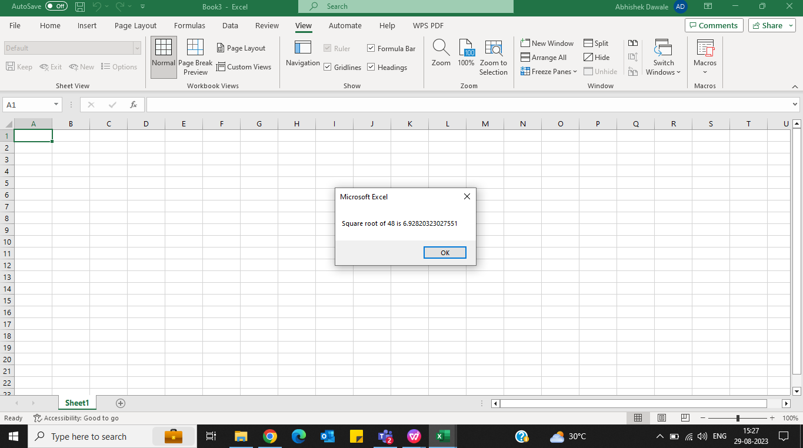

**6. What are the shortcut keys used to**

**a. Run the code**

**b. Step into the code**

**c. Step out of code**

**d. Reset the code**

Run the code : F5

Step into the code : F8

Step out of code : Shift + F8

Reset the Code: Ctrl + Break